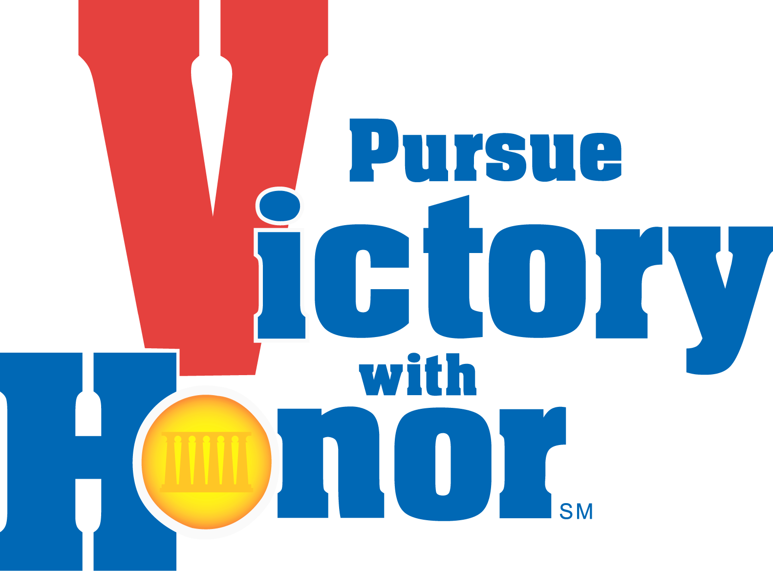
CIF LOS ANGELES CITY SECTION

Basketball Coaches Meeting
Girls: 4pm / BOYS: 6pm
Tuesday, October 15, 2013
Roybal LC Multi Purpose Room

A G E N D A

- Sign in/Pick up Packets/Call Meeting to Order – Dick Dornan

- League Break-Out Meetings – Dick Dornan
- Select League Manager and fill out form
- Review schedule and other league concerns
- Complete all information requested on League Summary Form

- Welcome/Introductions/Guests/Contents of Packets – Dick Dornan

- National Federation Rules Update – John Lozano (see website for new NFHS rules)
- New Rules / Points of Emphasis / Officiating

5. Issues for Discussion – John Aguirre
- CIF LA City Section/District Update
- Goldbook (Ch. 1, 2, 3, 5, 6, Sport Chapter, New Rules, Appendix)
- State CIF Transfer/Valid Change of Residence Policy
- Tournament Policies and Procedures
- Changes to schedule
- Hazing and Bullying
- Concussions- symptoms, precautions and protocol
- Physicals and paperwork
- Equipment
- Coaching Requirements- Rule 126- First Aid/CPR/Concussion Training, Coaching Education, Fingerprints
- Student Insurance-K&K Insurance www.student insurance-kk.com
- National Federation Coaches Association (Insurance)
- Social Media

6. Out of Season Contact – John Aguirre

7. Los Angeles Basketball Coaches Association – Kevin Kanemura & Joe Reed
- Division Placement
- Seeding Committee
- Game Report Survey
- Coaches Poll
- League Managers- duties and responsibilities (including All-League and All-City)
- All-City Selections- guidelines, due dates, criteria
- Coaches vs. Cancer Week

8. IAC Rules/Policies and Procedures – Dick Dornan (refer to handout)
- Eligibility rosters are due in the LAUSD office (Trent Cornelius) by November 18, 2013
- MaxPreps (roster, schedule, results)
- Nike ball contract
- Verify off campus sites
- BOM Coaching Representatives [East Region-Lorenzo Hernandez (Garfield) Brian Ota (Bravo)/Valley-Jonathan Sheriff (Chatsworth), TBD)/Coastal-Allen Hunt (Venice), Victoria Sanders (Narbonne)]
- “Pursuing Victory with Honor”
- Tournament Openings
- Fill out coaches info update & return TODAY

- Playoff Entry and Procedures – Dick Dornan (refer to handout)
- Review of Playoff Dates / Playoff Sites
- State Tournament Information

- MaxPreps presentation – Leland Gordon

- LAUSD items – Trent Cornelius

PLEASE RETURN ALL FORMS TO THE FRONT TABLE BEFORE LEAVING TONIGHT.

